**Additional steps need to implement to setup shadow-box on Raspberry PI**

**This document will show the steps about:**

* The additional steps need to do and the files need to check to make the shadow-box-V2 work normally on a raspberry PI 3 Mode-B when we follow the method shown in the Shadow-box v2 project from the Git (link: <https://github.com/kkamagui/shadow-box-for-arm>)

**Section 1: Additional steps and file need to check**

* 1. When we do the step [3.5.1. Copy OP-TEE OS with Shadow-Box for ARM and New Linux Kernel to Raspbian OS], make sure the ‘image’ was copied in the boot1 and boot folder:

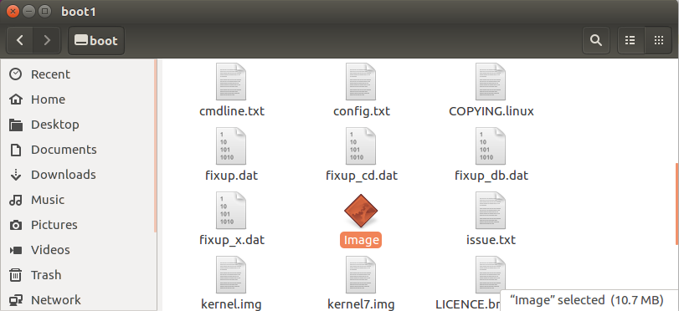

We also need to copy the file to boot1 folder by use cmd:

**$sudo gunzip -cd $HOME/shadow-box/gen_rootfs/filesystem.cpio.gz | sudo cpio -iudmv "boot1/*"**

Make sure the folder **4.6.3-17586g76cacae** is in the **rootfs/lib/modules** folder in the Raspberry PI’s SD card.

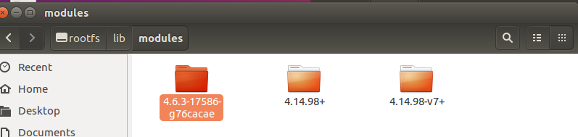

* 1. When we run the cmd “**$ sudo shadow_box_client –g**” in step [3.6.5. Activate Shadow-Box for ARM and Start Secure Pi], there will be no result shown. Check the file **shadow_box_client** in Raspberry Pi **/bin** folder: If the file size is less than 4.8MB, which means the file is not copied correctly. In our experiment, the file is an empty file with file size 1kb. So we need to make the file front the build computer again. In the computer which we build the shadow-box project **shadow-box/optee_examples_shadow_box_client/host** folder, find the executable file “**shadow_box_client**”. As show below:

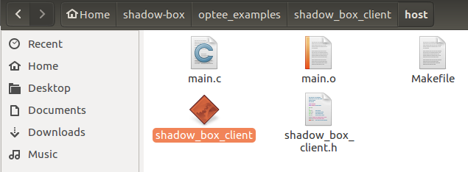

* If the executable file is not in the folder, use “make” to create it.

Copy the file **shadow_box_client** to Raspberry Pi’s **/bin** folder:

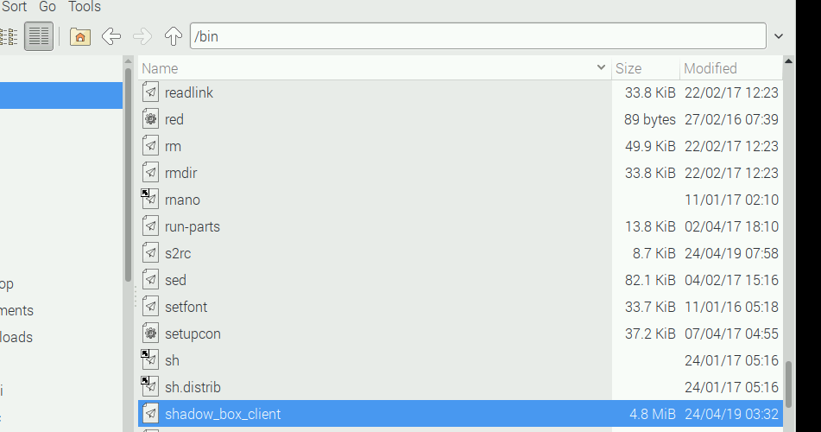

After copied the file, use the img_sign.sh to sign the program:

**$ sudo ./img_sign.sh /bin/shadow_box_client**

1.3 Before run the shadow box to protect the Linux kernel in [3.6.5. Activate Shadow-Box for ARM and Start Secure Pi!] By cmd **$ sudo shadow_box_client –s** we need to confirm the OPTEE related files are located:

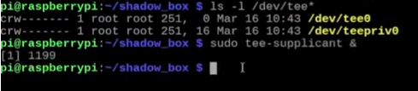

We also need to use the **$ sudo uname –r** to confirm the RaspbianLinux kernel version is 4.6.3-17586g76cacae instead of 4.17+ or anything else.

1.4 In the step [3.6.6. Check Your Secure Pi Remotely]

When do the first cmd:

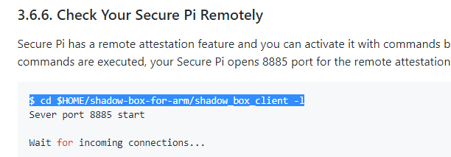

We Need to cd to $HOME/shadow-box-for-arm first then run the cmd **$ sudo shadow_box_client –l** , otherwise there will be an error.

----------------------------------------------- Last edited by LiuYuancheng at 25/04/2019----------------------------------------